**Project Proposal for**

**Smart للعقارات**

Openinig

**Welcome to our project proposal for Apartment Rental management system.**

**Our proposal outlines a comprehensive solution to automate and streamline the rental process, providing an efficient and user-friendly experience for both property owners and tenants.**

**We believe that our proposed solution will greatly benefit property management companies by simplifying their rental management process and reducing their workload.**

table of contents

1) Problem Definition

The problem that our project aims to address is the difficulty in finding suitable apartments for rent in the city. This problem arises due to the lack of a comprehensive and user-friendly platform that connects renters with available apartments. This problem affects both renters, who struggle to find suitable and affordable apartments, and property owners, who struggle to find reliable tenants.

Our proposed project aims to solve this problem by developing an online platform that allows renters to easily search and view available apartments, apply for rentals, and connect with property owners. Additionally, the platform will offer property owners a convenient and efficient way to list their available apartments, screen potential tenants, and manage their rental properties.

By developing this platform, we can provide a solution that benefits both renters and property owners, making the apartment rental process easier and more efficient for everyone involved.

2) Project Scope

The scope of the Apartment Rental project includes developing a web-based platform that allows users to easily search and view available apartments for rent in various cities. The platform will include features such as search filters, detailed apartment descriptions, photos, virtual tours, and the ability to schedule a viewing appointment. The project will also include a messaging system that allows users to communicate with property managers or property owners to ask questions and arrange apartment viewings.

The project does not include property management services such as tenant screening, lease agreements, rent collection, or maintenance requests. It also does not include any physical changes to the apartments or buildings themselves.

3) Goals and Objectives

The goal of our Apartment Rental project is to provide a user-friendly platform for people who are searching for apartments to rent. Our platform will allow users to easily search for available apartments based on their preferences, view detailed information about each apartment, and easily contact property owners for further inquiries or to schedule a viewing.

The objectives of the project are:

* Develop a comprehensive database of apartments for rent in various locations
* Create an intuitive user interface for searching and filtering apartments based on user preferences
* Provide detailed information about each apartment, including pictures, descriptions, and pricing
* Allow landlords to list their apartments and manage their listings through a secure platform
* Implement a secure and user-friendly system for communication between landlords and potential renters

These objectives align with our organization's strategic goals of providing innovative and user-friendly solutions to help people with their daily life activities. By creating a convenient platform for apartment rentals, we aim to simplify the process for renters and property owners alike, and ultimately improve the overall rental experience.

4) Project Plan

WBS (Work Breakdown Structure)

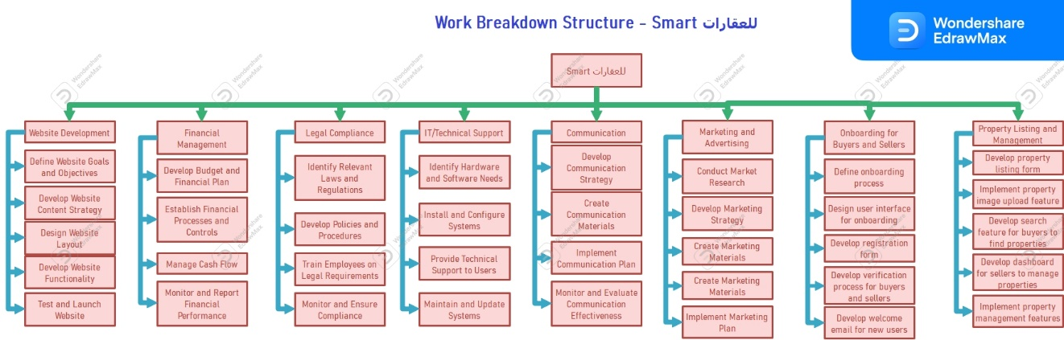

Gantt chart

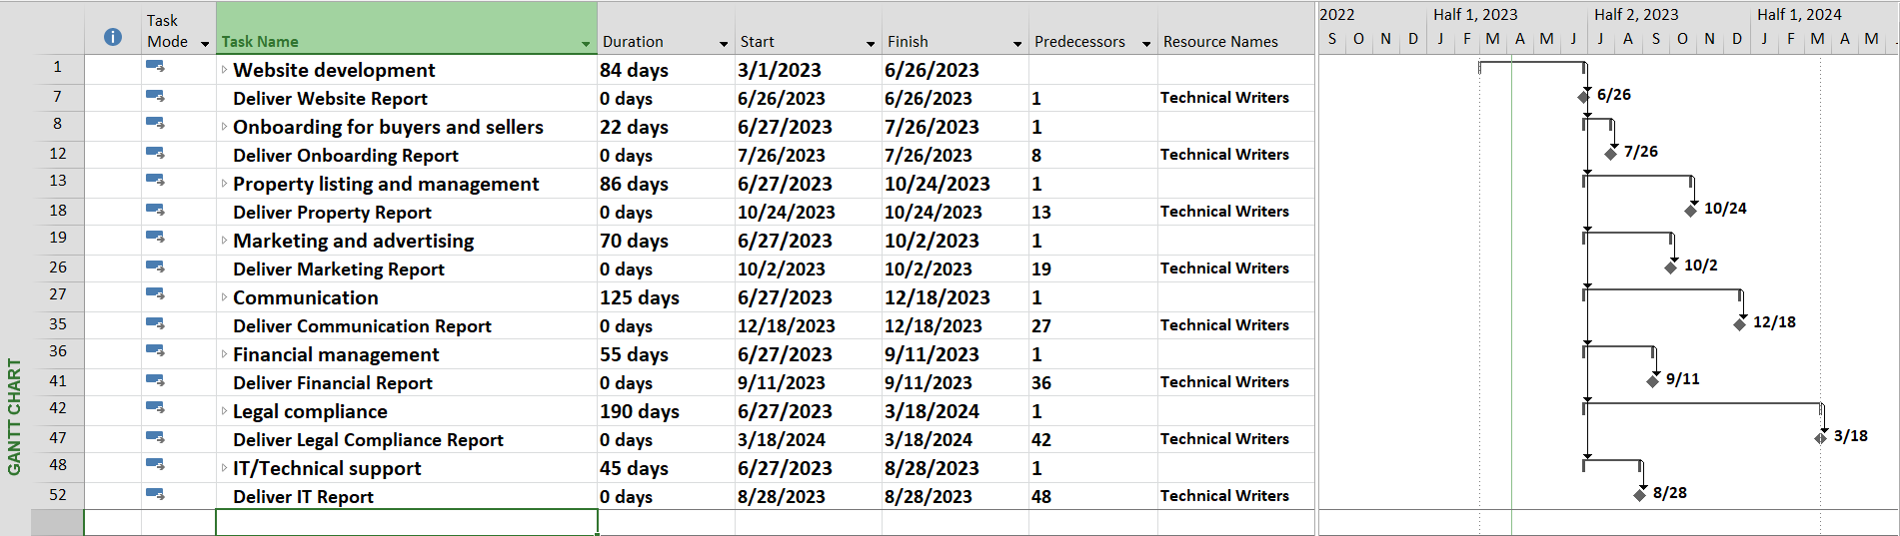

Bert chart

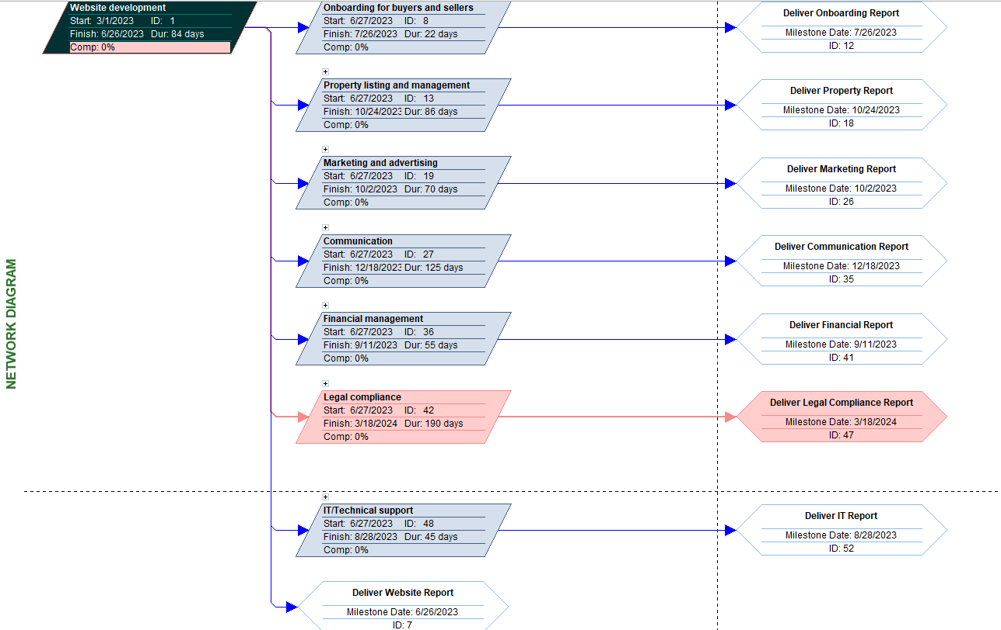

Resource Sheet

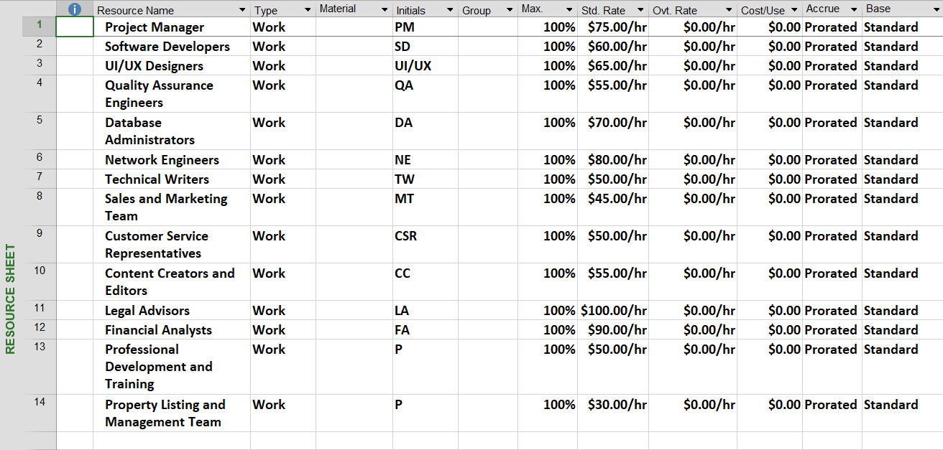

5) Stakeholders

1. Project sponsor: Responsible for providing funding and overall guidance for the project.
2. Project manager: Responsible for overseeing the project, ensuring that it stays on track, and coordinating with all stakeholders.
3. Development team: Responsible for developing the software and ensuring that it meets all requirements and specifications.
4. Quality assurance team: Responsible for testing the software and ensuring that it is bug-free and meets all quality standards.
5. End-users: Those who will be using the software to rent apartments and manage their rental agreements.
6. Property owners: Those who will be renting out their properties using the software.
7. Marketing team: Responsible for promoting the software and ensuring that it reaches the target audience.

6) Team Members

|  |  |  |  |  |
| --- | --- | --- | --- | --- |
| Member Name | First Skill | Second Skill | Third Skill | Fourth Skill |
| محمد عبد الرحمن احمد الخلاوى | Documenter | Presentator | UML Designer | Fluent in English both Oral and Written |
| وليد عبد المجيد الاعصر | Full Stack Developer | Experience in AI and Machine Learning |  |  |
| محمد رشدى توفيق سليمان | Front End | Documenter | UML Designer | Technical Support |
| سمر سيد عبد العال | Full Stack Developer. | Low Experience in AI | UML Designer |  |
| محمد جبرالله سيد | Back End | Low Experience in Front End | UML Designer |  |
| ياسر ايمن | Documenter | Speaker | Bug Hunter |  |

7) Potential Risks

1. Technical Risks:

These risks are associated with the development and implementation of the software. For example, there may be unforeseen technical issues that arise during development that could cause delays or result in the software not functioning as expected.

2. Financial Risks:

These risks are associated with the budget and financial resources needed to complete the project. For example, unexpected expenses may arise that could exceed the budget, or there may be delays in funding that could affect the timeline of the project.

3. Market Risks:

These risks are associated with the demand for the software in the market. For example, there may be changes in the market that could affect the need for the software, or there may be unforeseen competition that arises that could affect the adoption of the software.

4. Operational Risks:

These risks are associated with the operation of the software after it has been implemented. For example, there may be compatibility issues with other software or hardware, or there may be unforeseen user behavior that could affect the functionality of the software.

To mitigate these risks, we will develop a risk management plan that includes identifying potential risks, assessing the likelihood and impact of those risks, and developing strategies to mitigate or minimize the impact of those risks. We will also regularly monitor and review the risk management plan to ensure that it remains effective throughout the project.

8) Evaluation Plan

The success of the Apartment Rental project will be evaluated based on several factors, including the efficiency and effectiveness of the rental management system, user satisfaction, and financial performance. The following metrics will be used to evaluate the success of the project:

1. System efficiency: The response time of the system and the number of system crashes will be measured to ensure the system is efficient and reliable.
2. User satisfaction: User satisfaction surveys will be conducted to measure user satisfaction with the system's functionality, ease of use, and overall experience.
3. Financial performance: The financial performance of the project will be measured through the comparison of revenue generated from the rental properties before and after the implementation of the new rental management system.

The results of the evaluation will be documented in a project evaluation report, which will include an analysis of the project's performance and any recommendations for future improvements.

9) Estimated Budget

1. Personnel Costs:

* Project Manager: $10,000
* Software Developer: $20,000
* Quality Assurance Tester: $15,000
* Technical Writer: $5,000

2. Equipment Costs:

* Server: $2,000
* Computers/Laptops: $8,000
* Software Licenses: $3,000

3. Other Costs:

* Office Rent: $5,000
* Internet/Phone: $2,000
* Miscellaneous: $3,000

Total Estimated Budget: $73,000

Note:

This is an estimate, and actual costs may vary depending on the specific requirements of the project. The budget will be continuously monitored and updated throughout the project to ensure that expenses are kept within the allocated budget.

10) Project Summary

The Apartment Rental project aims to develop an online platform that streamlines the process of finding and renting apartments for tenants and property owners. The current process of apartment rental is complex, time-consuming, and error-prone. This project aims to address these issues by creating a centralized platform that connects tenants with property owners, automating the rental process, and providing a transparent and efficient renting experience.

The project scope includes the development of a user-friendly website and mobile application that allows tenants to search for apartments, schedule tours, and apply for rentals. The platform will also provide features for property owners to list their properties, screen potential tenants, and manage rental agreements.

The goals and objectives of the project are to provide a comprehensive solution that simplifies the apartment rental process, saves time and money for tenants and property owners, and improves the overall renting experience. The project will align with the organization's strategic goals and objectives by leveraging technology to improve the real estate industry.

The stakeholders of the project include tenants, property owners, real estate agents, and property management companies. The project team will consist of project manager, developers, designers, testers, and technical writers. The team will work together to ensure the project is delivered on time, within budget, and meets the project goals and objectives.

The project evaluation plan will measure the success of the project by monitoring user engagement, user satisfaction, and adoption rates. The budget for the project is estimated at $500,000, which will cover personnel, equipment, and supplies.

Overall, the Apartment Rental project will provide a much-needed solution to the complex and inefficient apartment rental process. The platform will improve the renting experience for tenants and property owners and will have a significant impact on the real estate industry.